5.115: a) The analysis is the same as that for the conical pendulum of Example 5.22, and so
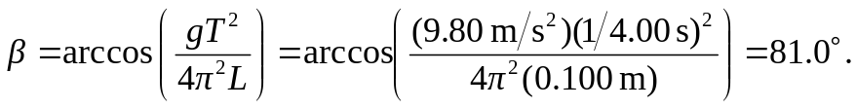
b) For the bead to be at the same elevation as the center of the hoop, 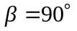 and 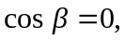 which would mean 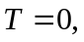 the speed of the bead would be infinite, and this is not possible. c) The expression for 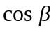 gives 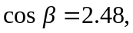 which is not possible. In deriving the expression for 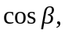 a factor of 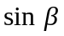 was canceled, precluding the possibility that 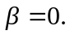 For this situation, 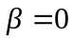 is the only physical possibility.

